WINDOWS PORTABLE COMPUTING TROUBLESHOOTING LAPTOP-1

11.1 DIFFERENCE BETWEEN LAPTOP AND DESKTOP MOTHERBOARDS:

1. For desktop computer motherboards, upgrading is very easy. For the ones who build their own computers, one can upgrade the components of the parts of [the desktop computer](https://ecomputertips.com/pros-and-cons-of-desktop-computers/) and even the motherboard.

2. In the laptop motherboard, it is not that powerful as the desktop motherboards. Having less space, the user cannot upgrade any component or parts of the laptop motherboard except [the RAM](https://ecomputertips.com/what-is-ram/).

3. The desktop computer’s motherboard is easy to customize because of extra space. After customization, the upgraded parts are easy to reconfigure and become powerful.

4. The customization of the motherboard for laptops is possible. But one cannot upgrade the motherboard except the RAM because of its small and packed size.

5. The reason for its expanded slots and more space motherboards in desktop computers allow easier upgrading.

6. Motherboards in laptops are very different from the desktop motherboards. They don’t have any expansion slots. Rather than having expansion slots and cards for parts like [sound cards](https://ecomputertips.com/what-is-sound-card/).

7. Incompatibility is an important factor. The [CPU and](https://ecomputertips.com/cpu-vs-core-vs-socket/) the motherboard should perfectly fit. The [CPU socket](https://ecomputertips.com/what-is-cpu-socket/) should be compatible with its chipset.

8.  The laptop motherboard which is designed for laptops will not be compatible with desktop.

CHECKING POWER CONNECTOR AND ADAPTOR PINS:

Important parmeters to look for in a compatible laptop power adaptor/charger:

PIN TYPE:

All Laptops have different pin sockets for power. Also power adapters do comes with different pin sizes, so first thing is to make sure that the power adapter pin matches the laptop power pin socket. Here are some different pin types shown in the picture.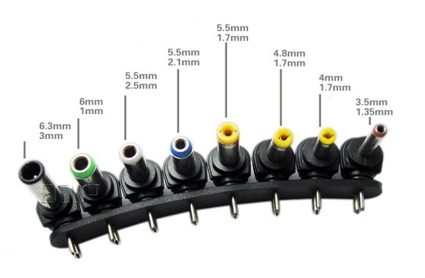

INPUT VOLTAGE:

Input voltage is the voltage supplied to your power adapter. In India usually it is 100-240V~. So make sure the adapter you are buying is having this value. Input voltage is always in AC (Alternating Current). Voltage is measured in Volts (V).

OUTPUT VOLTAGE:

Output voltage is the voltage supplied by the power adapter and it is always in DC (Direct Current). Make sure that the output voltage matches the output voltage specified for the particular laptop model.

AC ADAPTOR OF LAPTOP CIRCUIT DIAGRAM:

**AC adapters** convert a higher-voltage [alternating current](https://energyeducation.ca/encyclopedia/Alternating_current) to a lower-voltage [direct current](https://energyeducation.ca/encyclopedia/Direct_current) for use with devices that require a relatively constant [voltage](https://energyeducation.ca/encyclopedia/Voltage) (within a tolerance). Direct current is also required to recharge [batteries](https://energyeducation.ca/encyclopedia/Battery), making AC adapters essential for electronic devices like laptops and [cell phones](javascript:%20void(0)).[[1]](https://energyeducation.ca/encyclopedia/AC_adapter#cite_note-1) Older AC adapters waste quite a bit of [electricity](https://energyeducation.ca/encyclopedia/Electricity) in the form of [standby power](https://energyeducation.ca/encyclopedia/Standby_power), but recent regulations and subsequent innovations have reduced the amount of electricity wasted considerably.

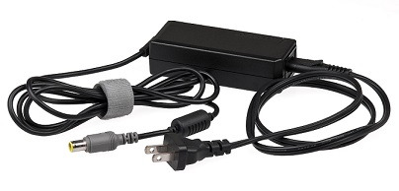

HOW IT WORKS ?

A simple AC adapter consists of a [transformer](https://energyeducation.ca/encyclopedia/Transformer), a rectifier, and an electronic filter. The transformer initially converts a relatively high-[voltage](https://energyeducation.ca/encyclopedia/Voltage) alternating current that is supplied by an [electrical outlet](https://energyeducation.ca/encyclopedia/Electrical_outlet) to a lower voltage suitable for the device being powered.[[2]](https://energyeducation.ca/encyclopedia/AC_adapter#cite_note-2)[[3]](https://energyeducation.ca/encyclopedia/AC_adapter#cite_note-3) A rectifier then converts alternating current into direct current. A rectifier then converts alternating current into direct current. There are two separate types of rectifiers: the half-wave rectifier and the full-wave rectifier.

**Half-wave rectifier**

The half-wave rectifier effectively blocks current flow in one direction through the use of a [diode](https://energyeducation.ca/encyclopedia/Diode) .This creates a pulsating direct current. Due to half of the current being blocked, much of the supplied energy is lost, and the mean voltage of half-wave rectified power is lower than that of full-wave rectified power.

**Full-wave rectifier**

There are several types of full-wave rectifiers. Rather than blocking the [electric current](https://energyeducation.ca/encyclopedia/Electric_current) in one direction, these rectifiers flip its direction so that a constant pulsing direct current is the output. A common type of full-wave rectifier is the full-wave bridge rectifier.

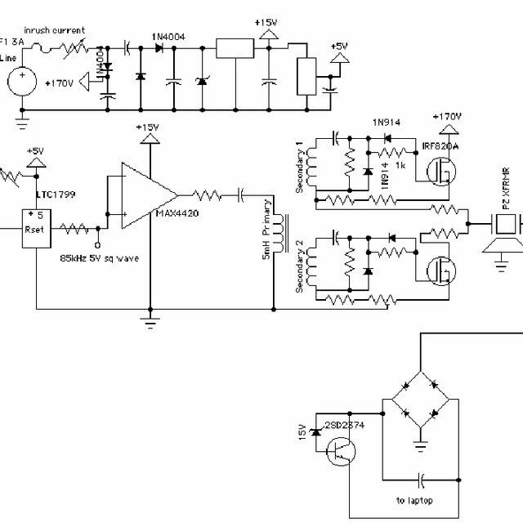

FAULT FINDING:

Low Battery Life

This has always been an issue for laptops since they first came onto the market because their batteries don’t last as long as desktop computers. These days however there are more reasons than ever for low battery life; one of the main reasons is that the battery itself degrades over time and you’ll end up with either a battery that can’t hold much power or worse, won’t charge at all.

Freezing / Lagging / Slow Response Time:

When we say freezing we’re not referring to when your computer suddenly stops working for no apparent reason (more on this later), but instead when it suddenly lags in response time when you press buttons or try to move around your screen. This problem often occurs when you have too many programs open at once so make sure to close any unneeded tabs before playing games etc.

Faulty Battery

It’s pretty self-explanatory; make sure your laptop is off and disconnected from the power outlet before removing the battery. If it seems like your battery is taking too long to charge, or not holding its charge as long as usual then you may need a new one (and this applies for any other removable parts such as RAM). It’s always best to try some basic fixes before replacing parts though, such as cleaning out the inside of your laptop with compressed air or replacing the thermal paste on your CPU. Finally, overheating can cause all kinds of problems so be sure that there are no clogged vents or fans.

Broken Screen / No Display

The most common laptop problem is a broken screen or no display. Whether the glass has shattered, the backlight has burnt out, or you’re experiencing poor color quality it’s always best to try some simple fixes before paying for an expensive [repair](https://computertechnicians.com.au/melbourne-laptop-repair/). If your laptop’s screen is completely black then make sure that the brightness isn’t turned all of the way down and if the colors are faded or distorted then plugging it into an external monitor could reveal whether you have a faulty video adapter cable.

 Battery Failure / Power Issues

If your battery seems to be dying too quickly after fully charging, or otherwise not working as well as usual then it may just need to be replaced . You can either choose to buy a new one from your manufacturer or an aftermarket company that sells batteries for a much lower cost.

Slow to wake up

If your laptop seems to be taking a long time to turn on, or regularly freezes when you try to open an application then it might be due to a full memory, which can often be resolved by freeing up the hard drive space. You can check how much space is being used by going into “Settings” and selecting “System.” Then select “Storage,” followed by “Used Space.” If it says anything above 20GB then you’re going- just delete anything that’s unnecessary and you should notice a significant improvement.

Blue Screen Errors

Blue screen errors are typically the result of faulty drivers or old hardware that needs updating. In some cases, your laptop might even have a virus, which can usually be resolved with the help of an antivirus application.

TROUBLESHOOTING VOLTAGE TRANSFER SECTION: